
DEPARTMENT OF THE ARMY

XXXXXXXXXXXXXXXXXXXX
XXXXXXXXXXXXXXXXXXXX
XXXXXXXXXXXXXXXXXXXX

OFFICE SYMBOL Date

MEMORANDUM FOR SEE DISTRIBUTION

SUBJECT: Arms Room Standard Operating Procedure

- Purpose: To provide specific operational physical security instructions to personnel having duties connected with unit arms room. These instructions are necessary to meet regulatory requirements as directed by references listed below.

- Scope: This SOP applies to all assigned and attached personnel.

- References:

- AR 190-11, Physical Security of Arms, Ammunition, and Explosives (AA&E).

- AR 190-13, The Army Physical Security Program.

4. Responsibilities:

- Physical Security Officer: The Physical Security Officer will be appointed in writing (See Annex A) and will assist the commander in developing security procedures for the arms room. The officer must be aware of existing regulations and insure that, as a minimum, a copy of the references above and this SOP are maintained in a binder in the arms storage facility. The Physical Security Officer, as a part of the unit self-inspection program, will conduct inspections of the arms room to verify the arms room is in compliance with all regulations and guidance. The Physical Security Officer must also keep the commander informed of any changes in regulations or local requirements.

- Unit Armorer: The armorer/assistant armorer will be appointed in writing by the commander (See Annex B) and enforce arms room security procedures. He will properly account for and secure all weapons, ammunition, and sensitive items stored in the arms room. The armorer will retain on file all pertinent regulations, this SOP, as well as all accountability files and completed arms room forms mentioned in this SOP.

- Arms Room Key and Lock Custodian: Primary/Alternate Arms Room Key and Lock Custodians will be appointed in writing (See Annex J), separate from the company Administrative Key and Lock Custodian. The custodian must monitor the keys once they have issued the operational set to the armorer to insure that positive control is being maintained and the keys are being properly signed for. The custodian will conduct all inventories and retain a copy on file.

5. Structural Standards:

- The arms rooms are validated by Facility Engineer personnel on a Security Construction Statement (DA Form 4604-R). The DA Form 4604-R will indicate the highest construction category met for storage of AA&E, be posted inside the arms room, and be revalidated every five years. An additional copy of the DA Form 4604-R will be retained on file in the S-2. Any structural change to the arms room will be coordinated with the Physical Security Division (PSD) of the Directorate of Emergency Services and Construction Branch of Public Works.

- Locally fabricated containers that secure AA&E must be certified by Facility Engineer personnel and a copy of the certification retained on file in the arms room. Any questions regarding certification of containers will be addressed to either the Physical Security Division or Public Works.

6. Security Requirements:

- The arms room is designated as a “Restricted Area”. The “Restricted Area” sign will be posted at eye level at the entrance to the arms room and will be visible at all times, to include when the door is open.

- The “Intrusion Detection System” sign will be constructed per Appendix F, AR 190-11 and affixed on all walls that contain an entrance to the arms room at eye level.

- An armed guard will be posted at the arms room whenever the arms room is secured and the IDS is not functioning.

- The entrance to the arms room will remain illuminated at all times and switches to these lights will be inaccessible to unauthorized personnel.

- Secondary padlocks used to secure containers and chains will meet the Commercial Item Description: case hardened steel shackle, heel and toe locking, and key retaining. Locks with NSN 5340-00-158-3807 (with chain) and NSN 5340-00-158-3805 (without chain) meet this requirement and are available through supply channels.
- All arms containers (if they weigh under 500 pounds) must be either secured to the structure or secured together with chain that is galvanized heavy duty hardened steel, welded, straight link, of at least 5/16-inch thickness (e.g. type 1, grade C, class 4, NSN 4010-00-149-5583, NSN 4010-00-149-5575, or NSN 4010-00-171-4427) and a approved padlock in paragraph e above so they have a combined weight of 500 pounds or more.

- When ammunition is stored in an arms room, a fire symbol will be prominently displayed on the outside of the arms room entrance. These will be removed when no ammunition is present. The symbols are as follows:

- Fire Symbol 3 - NSN 7690-01-081-9583 or 7690-01-081-9582 for DOD Classification 1.3 explosives. (See Hazard Classification Guide, Ft Drum Reg 700-3).

- Fire Symbol 4- NSN 7690-01-082-6709 or 7690-01-081-9684 for DOT Classification 1.4 Explosives. (Small arms, see Hazard Classification Guide, Ft Drum Reg 700-3

- Ammunition may be stored in permanent IDS protected arms rooms as follows:

- Ammunition for personally owned weapons will be stored in a separate locked container from military ammunition or any weapons. The amount of personally owned ammunition is limited to 500 rounds. Military ammunition will not be stored with any weapons.

- Salute ammunition is limited to 2280 rounds of 5.56mm blank (A080). This ammunition may be stored for the length of a salute detail, not to exceed 60 days.

- Small quantities of DOD hazard classification 1.3 and 1.4 ammunition authorized by the commander, in writing, may be stored in the unit arms room and will be kept to that amount determined absolutely necessary for the performance of essential mission requirements such as armed guard for IDS failure.

- Temporary storage, not to exceed 10 days, of small arms ammunition (DOD hazard classification 1.4) required for qualification/training purposes in permanent unit arms rooms, due to scheduling requirements, may be authorized in writing by the commander on a case by case basis.

- Operational load storage requirements must be coordinated in writing through DAO and G-3 for divisional units; DPTMSEC for non-divisional units; Post Fire Marshal, Post Safety Officer, Physical Security, and DOL Quality Assurance (Ammo) for written approval (site license).

- Division Ammunition Officer (DAO) is authorized to perform announced and unannounced arms room inspections with concurrence of the unit commander. Fire Dept., Safety, or QA (Ammo) personnel may perform scheduled or unannounced visits.

- SF 702 (Security Container Check Sheet) will be used to record entry/secure/check of vaults and weapons containers. All checks conducted by Staff Duty, CQ, etc. will be annotated on the SF 702.

- The combination to the arms room will be recorded on a SF 700. The top copy of the SF 700 will be affixed to the inside of the vault in such a manner as to preclude viewing by the general public. The remaining portion will be forwarded to Bn S-2). The S-2 will store it in the vault and afford it the same security as the arms room itself. Only personnel listed on the Unaccompanied Access Roster are authorized access to the SF 700.

7. Access:

- Unaccompanied access to the arms room will be limited to the lowest practical number of responsible personnel designated by the commander. The names and duty positions of these persons will be listed on an MFR, Subject: Unaccompanied Access Roster (UAR), signed by the commander, and posted inside the arms room in a manner which will prevent unauthorized disclosure. These persons will be authorized unaccompanied access only after they have satisfactorily undergone a command developed background check using DA Form 7281-R (Command Oriented Arms, Ammunition, & Explosives (AA&E) Security Screening and Evaluation Record) (see below). All personnel that are required unaccompanied access, with the commander's approval, will need to undergo a background check before unaccompanied access will be granted (i.e., armorer, AA&E Key Custodian, alternate armorer, alternate Key Custodian, etc.).

- At a minimum, the command-developed security screening will include:

- A personal interview with the individual conducted by the commander (DA Form 7281-R is in Physical Security Update 3).

- A Medical File Check.

- A Personnel Records Check.

- Local Law Enforcement Agencies Records Check. (Directorate of Emergency Services Records Section)
- A records check of local civilian law enforcement agency(s) in the area of the person's residence. (Civilians, Reservists, etc.)

- Local file checks will be conducted by the S-2. The original form (DA Form 7281-r) will be retained by the S-2 and a duplicate copy will be filed within the arms room until the individual leaves the unit. These checks will be updated every 3 years.

- Physical security inspectors (PSI) will be allowed accompanied access only upon presentation of PSI credentials (DA Forms 4261 and 4261-1). These credentials are red in color, have photographs attached, and are signed by both the Provost Marshal and the Inspector. The commander will be informed of all physical security inspections unless directed otherwise, prior to access of PSI personnel.

- Inspector General personnel will be allowed accompanied access only when directed by the Commander or his representative.

- All other personnel (facility engineers, investigators, etc.) will be allowed accompanied access as directed by the Commander or his representative.

- Personnel not mentioned above will be denied access to the arms room without the Commander's presence or specific permission. At no time will anyone not listed on an unaccompanied access roster be allowed into the arms storage vault unless escorted at all times by a person on the unaccompanied access roster. The Commander will be informed in the event that such escort is needed prior to access.

8. Inventories: The following is a list and an explanation of required inventories for all weapons, night vision devices (NVDs), and all other sensitive items as identified in DA Pam 710-2-1, which are stored in the arms storage facility:

- A physical count inventory will be conducted whenever custody of the arms room keys changes between authorized personnel. This physical count will include all weapons, ammunition, privately owned weapons and ammunition, and all sensitive items stored in the arms room. Both personnel will complete a DA Form 2062, and record the results of this inventory. Completed forms will be maintained in the arms room files until the next serial numbered inventory is accomplished and then destroyed. If a discrepancy is noted, the forms will be retained until the discrepancy is resolved.

- While in the field, arms and ammunition (as well as personnel and equipment) will be accounted for daily. The results of this daily inventory will be recorded on a duty log or journal.

- A monthly serial numbered inventory of all weapons, NVDs, privately owned weapons, and all other sensitive items maintained within the arms room will be conducted by disinterested personnel (which excludes any armorer or physical security officer) with the rank of NCO (CPL or above), warrant officer or commissioned officer. The same person will not conduct consecutive inventories. Monthly inventories will be conducted IAW procedures outlined in DA Pam 710-2-1. The results of this inventory will be recorded on an MFR (Annex H), which may be preprinted with weapon serial numbers IAW Para 9-11b(4), DA Pam 710-2-1, along with a cover memorandum (Annex I) or the Standard Property Book System (SPBS). If the SPBS is utilized, POWs, ammunition etc. must be listed when applicable. Completed forms will be maintained in the arms room for two years, unless a discrepancy is noted. Forms recording discrepancies will be retained for a period of four years.

- When inventory discrepancies are noted, immediate action IAW the regulations and directives must be taken to resolve the discrepancy.

- Prior to the deploying unit's departure from home station, a 100% serial-numbered inventory of all arms, ammunition, and other sensitive items will be conducted.

- After the unit is uploaded, a responsible Officer/NCO (CPL or above) of the deploying unit and a responsible Officer/NCO of the rear detachment remaining at the home station will conduct a joint serial numbered inventory of all items remaining in the deploying unit's arms room. The results of this joint inventory will be recorded as noted in paragraph 8d above, and a copy of the joint inventory will be provided to the Rear Detachment Commander.

- If separate arms rooms are jointly storing weapons during a deployment, the receiving arms room will do a joint serial numbered inventory with the losing arms room and a hand receipt will be issued to the losing arms room. Weapons from different companies will be stored in separate racks from each other in the consolidated arms room when possible. The gaining unit will be responsible for security, issuing and receiving all AA&E, and for all required inventories. Arms racks for different units will be marked as to whose weapons are stored in each rack.

- Upon return of the unit, a joint serial numbered inventory will be conducted of all items in the arms room prior to the unit's stand-down and return of deployed equipment into the arms room.

- After all AA&E items including deployed AA&E items are returned to their proper unit arms room, a 100% serial numbered inventory will be conducted.

- All privately owned weapons will be inventoried in the same manner as military AA&E.

- Annual Property Book Officer Inventory.

- Change of Command Inventory.

9. Records: All completed forms will be maintained in the arms room and made available to inspectors when required. Documentation required will include, but not be limited to the following: MTOE/TDA authorizations, DA Form 5504s, changes in authorized or available weapons, inspections and findings, appointment orders, issue and turn in sheets, LRCs, and all inventories, to include key and lock inventories.

10. Issue/Receipt of Weapons (DA Pam 710-2-1, Para 5-5).

- Weapons and ammunition (if required) will be issued only to those individuals that require them for duty or scheduled maintenance.

- Weapons issued for less than 24 hours requires the soldier surrender an Equipment Receipt (DA Form 3749). The armorer will remove the weapon from the rack and place the card in the slot. If the individual does not have a DA Form 3749 then a DA Form 2062 (Hand Receipt) will be prepared and placed in the slot.

- Weapons issued for more than 24 hours will be signed out and in on a control log after the individual surrenders an Equipment Receipt Card (DA Form 3749). The card must be completely filled out and signed, in ink, by the cardholder and responsible officer. The control log will contain date/time of issue, nomenclature and serial number of item, and signature of the individual as it appears on DA Form 3749. The card will be placed in the rack when the weapon is removed, and the rack re-locked. In event of general issue for maintenance or training, the racks may be unlocked until issue is complete. When weapons are returned the control log will be annotated with the date/time of return and the initials of the armorer accepting the weapon back. The weapon will be placed back in the rack and the DA Form 3749 will be returned to the soldier. The completed control log will be retained until the next serial number inventory, and then destroyed if no discrepancies are noted.

- The unit armorer will maintain a Master Authorization List (MAL) which includes the name and unit of the soldiers, what weapons and other sensitive items the soldiers are authorized to receive, and the equipment receipt number. The MAL will be kept updated to show personnel changes. The MAL will be posted in the arms room out of view of the general public.

- Weapons will NOT be issued under the following conditions:

- To any individual who smells of alcohol even if the individual does not appear drunk, unless directed by the Commander.

- To any individual who appears to be under the influence of alcohol or drugs of any type.

- To any individual not on duty, unless directed by the Commander.

- To any individual without their Team Chief/Squad Leader/Platoon Sergeant present, unless authorized by the Commander or the 1SG.

- The day gate will be utilized to keep out unauthorized personnel whenever the arms room is opened for issue or receipt of weapons.

- During emergency conditions or alerts, each card may be turned in for a weapon, for less than 24 hours, without being signed out on a control log. However, upon termination of an alert or emergency condition, which exceeds 24 hours, a special serial numbered inventory will be conducted.

11. Storage of Tools and High Value Items:

- Tools such as hammers, bolt cutters, chisels, crowbars, hacksaws, cutting torches, and similar items which could assist in gaining unauthorized access to the arms room/ weapons will not be stored near the arms room unless secured. These tools may be stored in an adjacent supply room if stored in a locked container. When an arms room is the only secure location available, such tools will be stored in a locked container in the arms room.

- High value items such as field glasses, compasses, watches, etc. subject to pilferage will not be stored in the arms room without Commander's written authorization. If these items are stored in the arms room, written authorization by the Commander will list each item by name and quantity (see Annex I), and these items will be secured in a locked container separate from AA&E.

- Storage and Accountability of Night Vision Devices (NVDs):

- Home station physical protective measures: All NVDs will be locked in a steel container that is secured with an authorized secondary padlock. Further, the container will be securely affixed to an internal structure with an authorized chain and a secondary padlock.

- Protective measures outside of the unit area: During training exercises and unit deployments, all NVDs not in active use will be secured in a locked container inside a secure van, trailer, armored vehicle, or similar type holding facility that is protected by a security fence or posted guard.

- Authorized alternate physical protective measures: All NVDs will be secured inside the unit's arms room inside locked cages separate from any arms or ammunition with a secondary padlock. Cages will either be permanently affixed to the internal structure or affixed to the internal structure with an authorized chain (at least 5/16") and a secondary padlock. The Commander will authorize storage of NVDs in the arms room in writing.

- Key Control for NVDs stored in the arms room will be conducted in the same manner as arms room keys.

- All NVDs will be inventoried with the same frequency and in the same manner as assigned weapons. IAW weapons inventory policies and procedures, secured containers with NVDs stored therein will be physically opened and the NVDs accounted for by serial number.

12. Privately Owned Weapons and Ammunition:

- All privately owned handguns must be registered with the State of New York. Handguns owned by military personnel and not registered in the state of New York will be secured in the unit arms room for safe keeping until they are properly registered.

- All privately owned weapons must be registered with the Directorate of Emergency Services. This must be accomplished within 3 working days of the weapon's arrival on the installation.

- All weapons not secured in private quarters will be stored in the unit arms room in a locked container.

- Personnel residing in unit billets will store firearms, ammunition, and other authorized weapons in their unit's designated arms room, whether or not they possess a license (AR 190-11) unless they have arranged for other authorized storage of their weapons. The keeping or storage of firearms, ammunition, and other weapons in individual barracks rooms or in privately owned vehicles on this installation is strictly prohibited.

- A hand receipt and one copy of DA Form 3749 will be completed by the armorer when weapon(s) are turned in to the arms room. Proof of post registration must be presented to the commander upon storage of weapon(s) in arms room. Personnel will retain the DA Form 3749 after having the Commander sign the back.

- All incoming personnel will be briefed on these requirements. (Security Education, General Physical Security SOP)

- Privately owned weapons and privately owned ammunition will be secured in separate locked containers from military AA&E within the arms room. Issue and receipt of privately owned weapons will be accomplished in the following manner:

- The unit commander will authorize the removal of privately owned weapons on a case by case basis, in writing.

- Weapons will be issued to personnel presenting DA Form 3749 and written authorization to the armorer. When a weapon is returned to the arms room, the DA Form 3749 will be returned to the service member.

- All privately owned weapons will be signed out on a separate weapons control register. The same form will not be utilized for military and privately owned weapons.

- Privately owned weapons will not be issued to any individual appearing to be under the influence of alcohol or any drug.

- A copy of state handgun registration requirements will be posted on the unit bulletin board. New York State firearms laws include the following:

13. Transportation of Weapons:

- Movement security criteria does not apply to arms and ammunition issued to individual soldiers or units when performing mission requirements.

- When weapons or ammunition are moved for maintenance, repair, transfer or location on or off post, or relinquishment because of manning changes, the following requirements will be met:

- A minimum of two personnel, a driver and a guard, must be used to transport category II weapons (M16s, .50 caliber machine guns, etc., see Para 7-10, AR 190-11). Either the driver or the guard must be a NCO (E-5 or higher), Commissioned Officer, Warrant Officer, or DOD civilian of equivalent grade. Category I and II arms, ammunition or explosives will be provided armed guard surveillance when transporting off the installation.

- The vehicle containing the weapons or ammunition must be attended at all times by the driver or guard. A vehicle is attended when at least one of these individuals is in the cab of the vehicle and awake, or within 10 feet of the vehicle and has unobstructed view of the vehicle.
- One individual must remain with the vehicle during on and off loading of weapons or ammunition.

- It is prohibited to carry, move, or store military AA&E in privately owned vehicles either on or off the installation.

- Those individuals performing duties under armed guard surveillance must be given instructions on the use of deadly force. Individuals must also sign and date a statement that the instructions are understood and will be followed.

14. Deployment of AA&E Items. (NOTE: It is recommended the below procedures be incorporated into each unit's TACSOPs where applicable.)

a. The deploying commander will establish and enforce procedures for securing deployed AA&E based on an assessment of the threat, objectives, location, and duration of the deployment. The following guidelines apply:

- AA&E will be under continuous positive control.

- AA&E will not be left unattended or unsecured.

- Persons charged with custody of AA&E will have the capability to sound an alarm if a forceful theft is attempted.

- A response force will be available to protect the AA&E. Where available, Military Police support will be coordinated and utilized as the response force.

- A system of supervisory checks will be established to ensure all personnel comply with security procedures. Supervisory checks of the AA&E holding area will be made to ensure the AA&E being guarded have not been tampered with.

- Control of ammunition and explosives during field training or range firing will be monitored closely by all Officers and NCOs. Upon completion of training, the area(s) will be policed and unused ammunition and explosives collected for turn-in. A shakedown inspection will be conducted prior to departing the training area to ensure unused ammunition and explosives are not retained by unit personnel. Close supervision by Officers and NCOs can eliminate most security problems in the training area.

- Selection of personnel to perform guard duties at AA&E holding areas will be closely monitored by commanders to ensure only responsible individuals are assigned to duty.

15. Individual Weapons Security:

- Each weapon issued for training, operations, or any other reason will be carried on the person or individual to whom issued at all times or it will be properly secured. Except during emergencies (terrorist attack, military attack, or other declared by the commander), weapons will not be issued to any person other than the weapons holder unless that person is charged with the security of operational weapons.

- Proper security is provided when weapons are under continuous surveillance by a dedicated guard (Category I and II AA&E) and in locked racks or containers, or stacked.

- Personnel medically evacuated during training exercises will relinquish their weapon(s) to the armorer, immediate Chain of Command, or highest-ranking Service Member. This person will either accompany the evacuation team or leave the weapon(s) in the field arms storage area. The armorer will annotate on the weapons sign-out sheet that the weapon has been returned and retain the weapons card(s) with the weapon(s) until the Soldier returns to duty.

- During training and field exercises, pistols and revolvers issued to persons will be secured by either a locally made lanyard or military issue field lanyard. Unloaded pistols and revolvers that lack a device to affix the lanyard will be secured by running the lanyard through the pistol trigger guard and secured to the Soldier's uniform. A lanyard will not secure a pistol or revolver through the trigger guard if the weapon is loaded.

16. Inert and Expended Ammunition and Explosives:

- Inert and expended LAW launcher tubes and rocket launcher M190, with M73 sub-caliber practice rocket, used as training devices are vulnerable to pilferage, misuse, or conversion to live ammunition. Such devices or training aides will be conspicuously marked to prevent accidental turn-in or turn-in as live fire residue. Those items, which can be converted to live ammunition or explosives, will be accounted for and secured as Category IV, live ammunition and explosives.

- Inert and expended LAW launcher tubes used as training devices will be controlled as follows:

- After use, launcher tubes will be properly turned-in to the Supply Support Activity/Ammunition Supply Point (SSA/ASP) and reissued to the using unit by the SSA/ASP to support their unit training. Units will account for reissued LAW launcher tube training aids on property books.

- Each launch tube must be clearly marked "INERT" or "EMPTY" and be drilled with four 1/4" holes that will not interfere with its training operation.

- Tubes converted to the M190 launcher will be conspicuously labeled as "M190", locally assigned a serial number, and controlled/secured as Category IV arms. Also, M190s will be inventoried as any other weapon on the unit's property book.

17. Missing/Lost Night Vision Devices, Weapons, and Ammunition:

- Upon discovery of loss, the recovery of NVDs or AA&E becomes the unit's sole mission. All training and/or maneuvers will stop and a total unit effort will be directed toward recovery.

- The unit will notify the chain of command, the Military Police Desk Sergeant and the Installation Physical Security Division to receive assistance or guidance on any additional reporting requirements.

- Commander will assemble and brief all unit personnel concerning the facts that led to the loss of the item and inspection procedures to recover the property.

- Commanders will initiate a detailed search to include a complete inventory of assigned AA&E.

18. Emergency Actions:

- In the event the armorer on duty suspects that a robbery or attack is about to take place, he will immediately take the following actions:

- Activate the duress alarm.

- Lock the inner door or close the vault door and lock it, where applicable.

- Call the Military Police, the SDO, and notify the Chain of Command.

- Go to the corner of the room on the same side as, but away from, the door and wait for the Military Police response force.

- In the event the arms room cannot be secured and the weapons remain inside, the Commander will post a guard.

19. Arms Room Keys and Locks:

- Key/Lock Custodian:
- The Arms Room Key and Lock Control Custodian and Alternates must be appointed in writing (see Annex D).

- The Custodian's duties include:

- Ensuring proper custody, handling, and accountability of the arms room keys and locks.

- Maintaining key control registers (DA Form 5513-R) and other records (i.e., inventories, investigations, and inspections) (see Annex K).

- Conducting semiannual inventories of assigned keys and locks in order to maintain administrative accountability for keys and locks. Keys and locks will also be inventoried upon loss, breakage or compromise of any key or lock in the arms vault.

- Establish a roster of personnel, to include custodian and alternates, authorized to receive keys from the Commander or his/her appointed Custodian (see Annex D). This roster will be kept current and protected from public view.

- Procedures:

- A Key Control Register, DA Form 5513-R, will be maintained to properly document key issue, turn in, and transfer of custody of the arms room keys (see Annex K), as well as to account for all keys and locks in the system, to include reserve keys and lock and IDS keys/cards. (NOTE: When issuing keys, insure that individuals print their name as well as sign for the keys.)

- The primary container keys will be kept on a ring and maintained in an ammunition can modified in a manner which allows it to be locked with an approved padlock and secured to inner arms vault structure with chain in the same manner as the arms room containers. The keys to the arms room key box, day gate key and proximity card will be turned into the AA&E key custodian at the end of duty.

- The duplicate sets of keys will be kept on rings and placed in a sealed envelope or locked container. The locked container or sealed envelope will then be signed over to the S-2, and secured in the S-2's safe. This transfer will be recorded on a DA Form 2062, Hand Receipt (see Annex L). The S-2 will sign for a locked/sealed box. A copy of the appointment orders for Primary/Alternate Key and Lock Custodian (see Annex J) will be maintained with the duplicate set of keys. Only personnel appointed as Primary or Alternate Arms Room Key and Lock Custodians will be authorized to sign for the duplicate set of keys maintained by the S-2. The keys to the lock that secure the duplicate key box will be maintained and accounted for in the same manner as the keys to primary set.

- The reverse side of DA Form 5513-R (see Annex K) will be used to record all key and lock inventories for arms room keys. The Key and Lock Custodian conduct inventories every six months or when there is a change of custodian(s) and the inventory records will be retained for a period of one year. Duplicate keys will be inventoried at the same time and in the same manner as the primary keys.

- After each key serial number on the DA Form 5513-R, the number of keys (to include the duplicate set) will be inserted in parentheses. An asterisk (*) will precede the first block, and below the Key Control Register Column a statement will indicate the location of the duplicate keys (see Annex L).

- Any discrepancies will be reported to the commander when discovered.

- Completed forms will be maintained in the arms room files.

- DA Form 5513-R will be retained for 90 days, and then destroyed. (NOTE: Ensure that any DA Form 5513-R utilized for inventory purposes are kept for a period of 1 year.)

- Keys will not be removed from the installation. When arms room keys are not stored/ secured within the unit’s arms room, keys will be secured by the Staff Duty. If the primary keys are maintained by the Staff Duty, only those personnel having unaccompanied access to the arms room will be allowed to receive the keys from the Staff Duty.

- When padlocks are opened to allow access, they must be locked on the hasp and keys removed to prevent compromise.

- At no time will the arms room keys be left unattended or unsecured.

- The commander will be notified immediately if any of the keys are missing, lost, misplaced, or stolen. A guard will be posted until the affected locks or cores are replaced.

- IDS key/card procedures are covered in the IDS Standard Operating Procedures.

- Master keying is prohibited.

- Padlocks and keys, which do not have a serial number, will be given one.

FOR THE COMMANDER:

Encls FIRST M. LAST
Annex A. - Sample Appointment XXX, XX
Orders for Unit Physical Security Officer Commanding
Annex B. - Sample Appointment Orders for Unit Armorer/Assistant Armorer.
Annex C. - Sample Arms Room Unaccompanied Access.
Annex D. - Sample Arms Room Key Access Roster.
Annex E. - Sample Request for Local Records Checks.
Annex F. - Sample Unaccompanied Access Interview.
Annex G. - Sample Monthly Serial Number Inventory.
Annex H. - Sample MFR Arms Room Monthly Inventory.
Annex I. - Sample MFR authorizing the Storage of High Value/Sensitive Items.
Annex J. - Sample Appointment Orders for Primary/Alternate Arms Room Key and Lock Custodian.
Annex K. - Sample Arms Room Key Control Register, DA Form 5513-R.
Annex L. - Sample DA Form 2062 Hand Receipt for duplicate set of keys to S-2.
Annex M. - Sample Weapons Control Log.
Annex N. – Security of Deployed AA&E Items.

DISTRIBUTION:

ANNEX A (SAMPLE APPOINTMENT ORDERS FOR UNIT PHYSICAL SECURITY OFFICER) TO ARMS ROOMS STANDARD OPERATING PROCEDURES

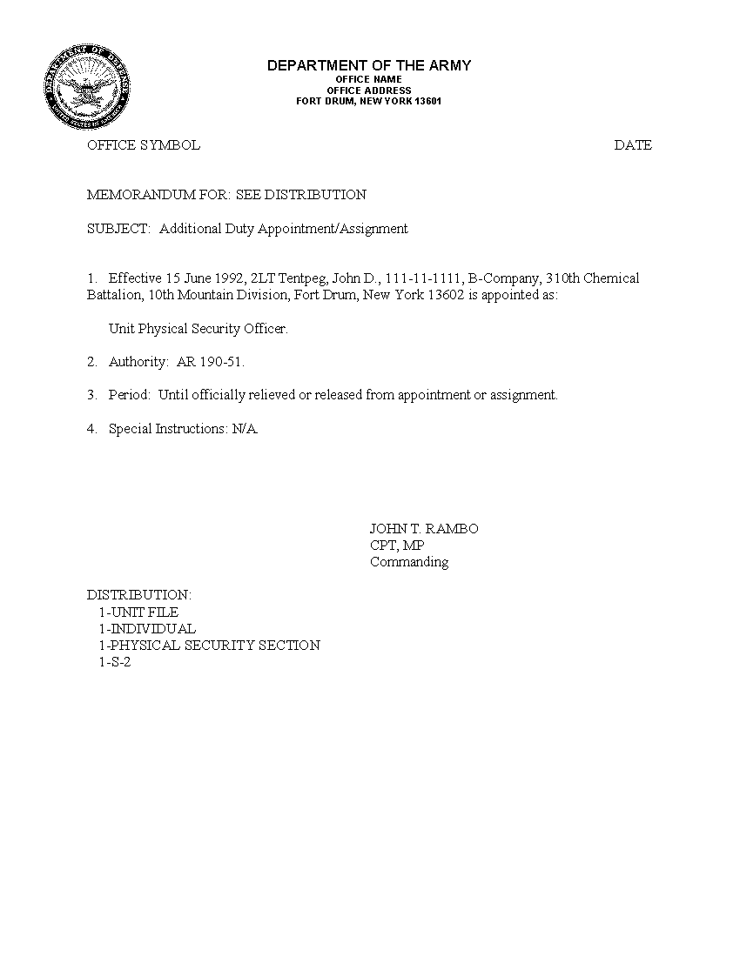
ANNEX B (APPOINTMENT ORDERS FOR UNIT ARMORER/ASSISTANT ARMORER) TO ARMS ROOM STANDARD OPERATING PROCEDURES

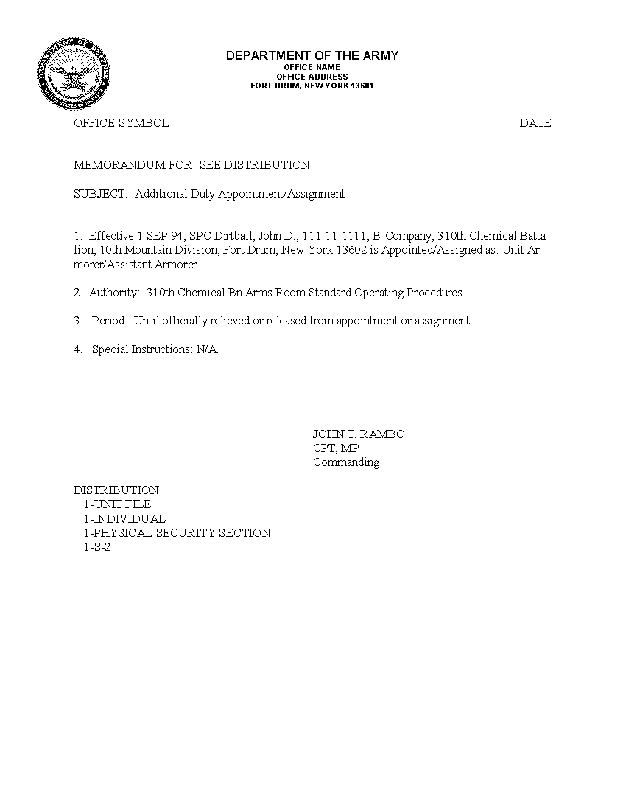
ANNEX C (UNACCOMPANIED ACCESS ROSTER) TO ARMS ROOM STANDARD OPERATING PROCEDURES
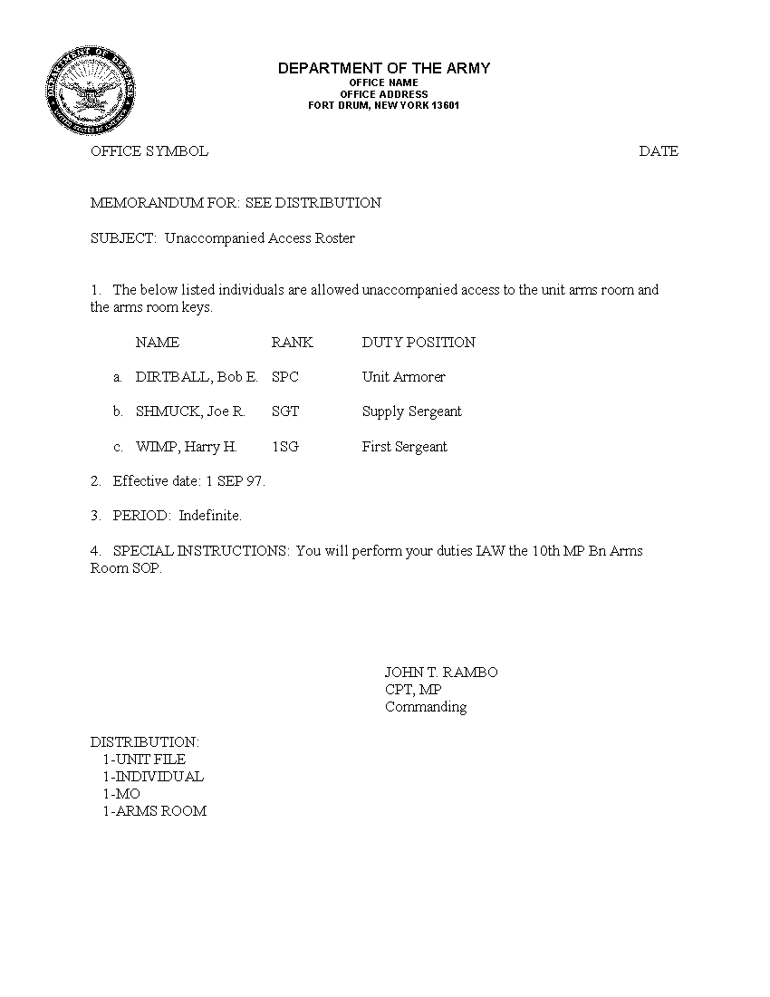
ANNEX D (ARMS ROOM KEYS ACCESS ROSTER) TO ARMS ROOM STANDARD OPERATING PROCEDURES
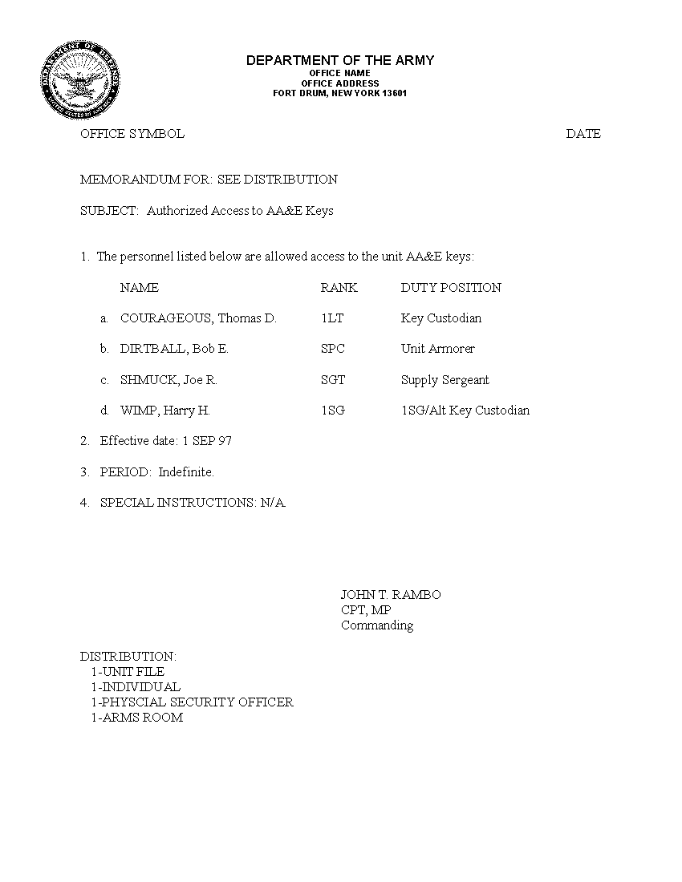
ANNEX E (SAMPLE REQUEST FOR LOCAL RECORDS CHECKS) TO ARMS ROOMS STANDARD OPERATING PROCEDURES

INSERT EXAMPLE
ANNEX F (UNACCOMPANIED ACCESS INTERVIEW) TO ARMS ROOM STANDARD OPERATING PROCEDURES
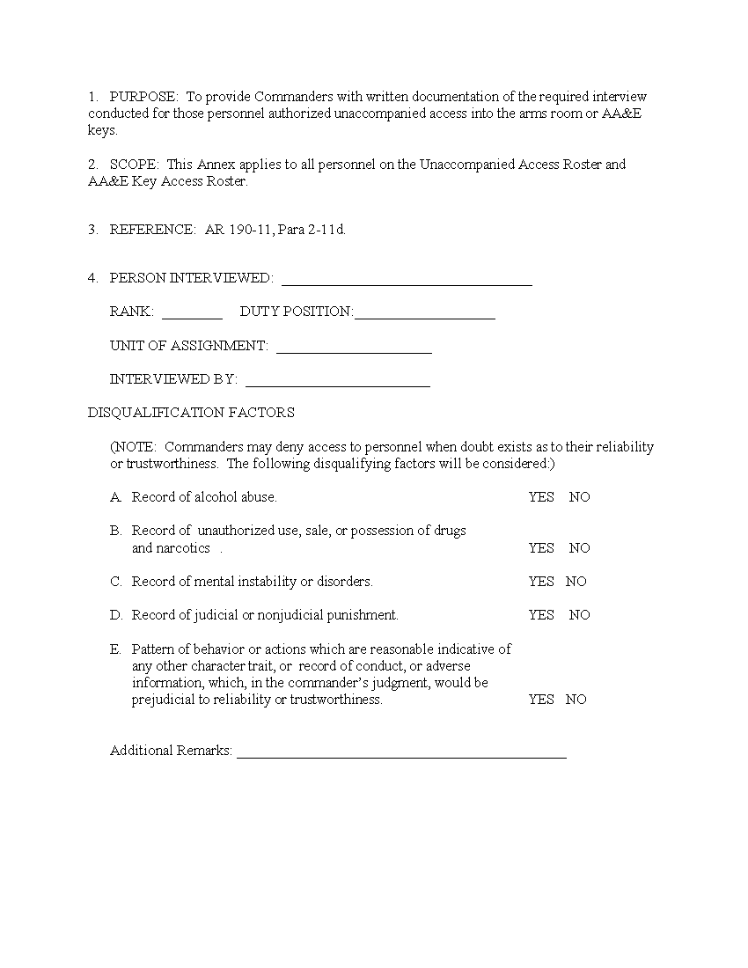ANNEX G (SAMPLE MONTHLY SERIAL NUMBER INVENTORY OF WEAPONS, SENSITIVE ITEMS, AND PRIVATELY OWNED WEAPONS) TO ARMS ROOM STANDARD OPERATING PROCEDURES

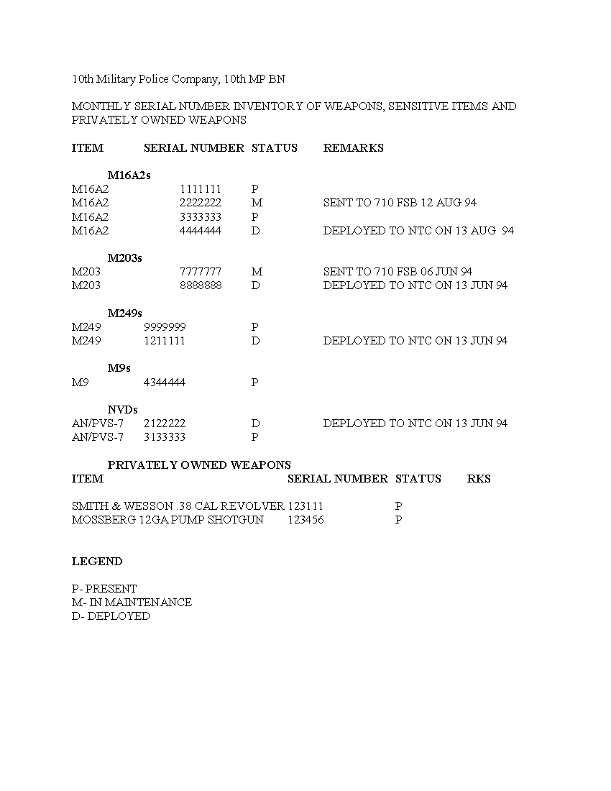ANNEX H (MFR, ARMS ROOM MONTHLY SERIAL NUMBER INVENTORY OF WEAPONS, SENSITIVE ITEMS AND PRIVATELY OWNED WEAPONS) TO ARMS ROOM STANDARD OPERATING PROCEDURES

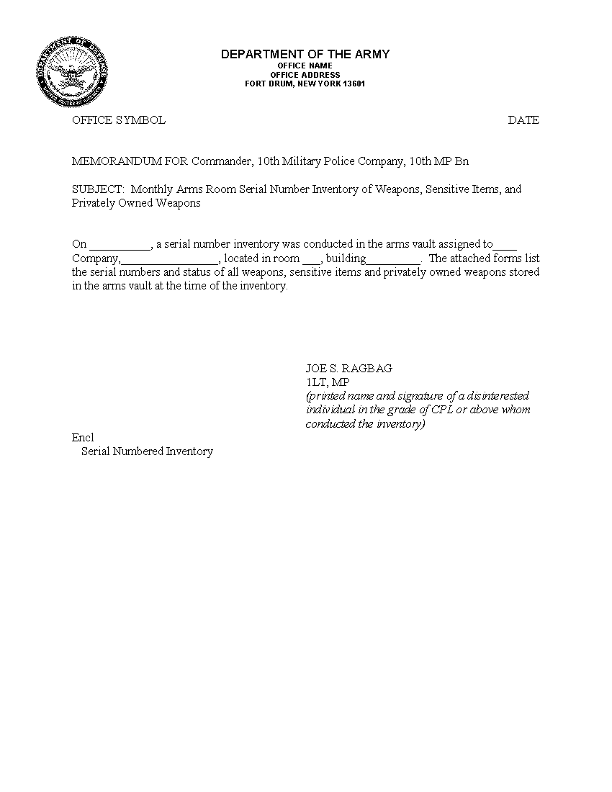ANNEX I (SAMPLE MFR AUTHORIZING THE STORAGE OF HIGH VALUE/ SENSITIVE ITEMS IN THE UNIT ARMS ROOM) TO ARMS ROOM STANDARD OPERATING PROCEDURES

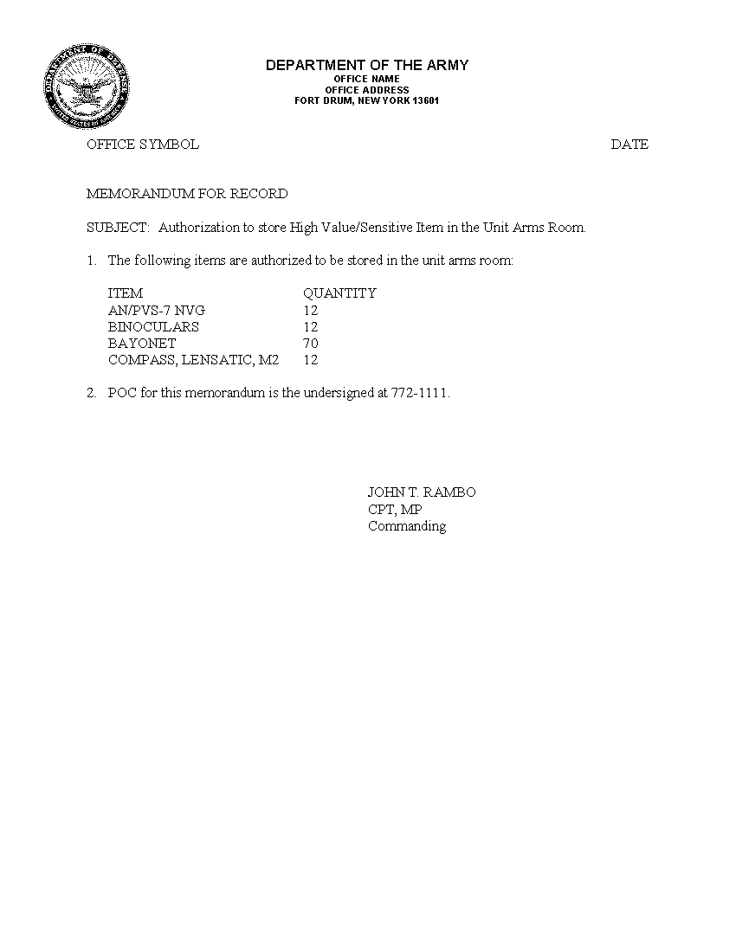ANNEX J (APPOINTMENT ORDERS FOR PRIMARY/ALTERNATE ARMS ROOM KEY AND LOCK CUSTODIAN, 2ND EXAMPLE) TO ARMS ROOMS STANDARD OPERATING PROCEDURES

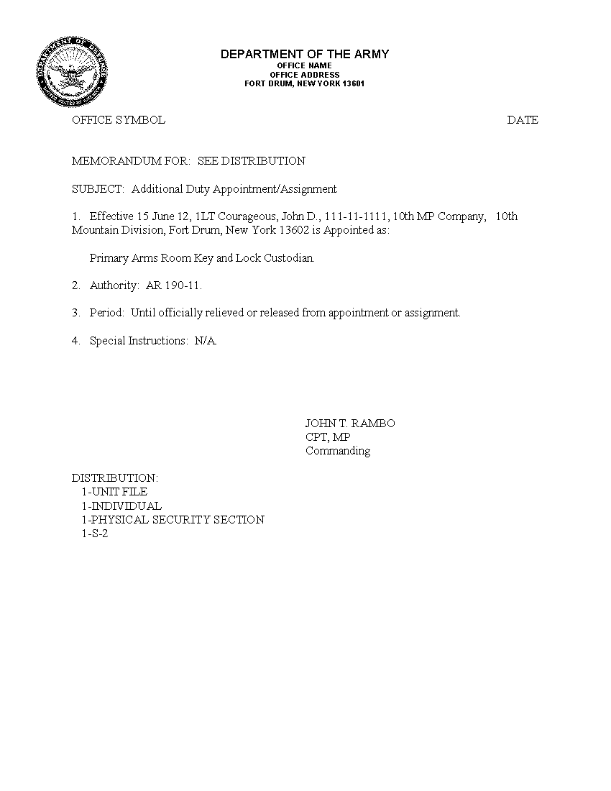ANNEX K [SAMPLE KEY REGISTER (DA FORM 5513-R)] FRONT PAGE TO ARMS ROOM STANDARD OPERATING PROCEDURES

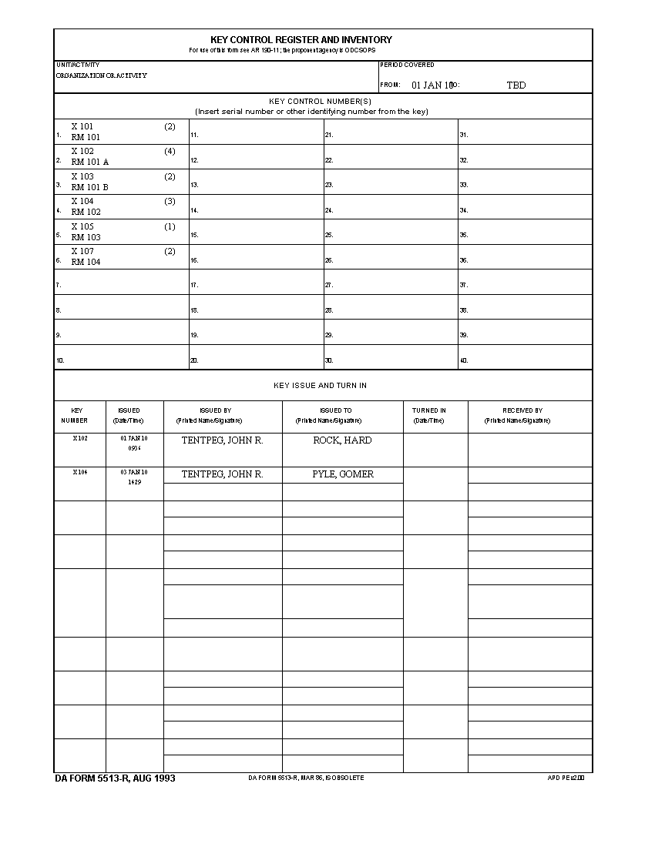
ANNEX K [SAMPLE KEY REGISTER (PAGE 2, DA FORM 5513-R)] TO ARMS ROOM STANDARD OPERATING PROCEDURES
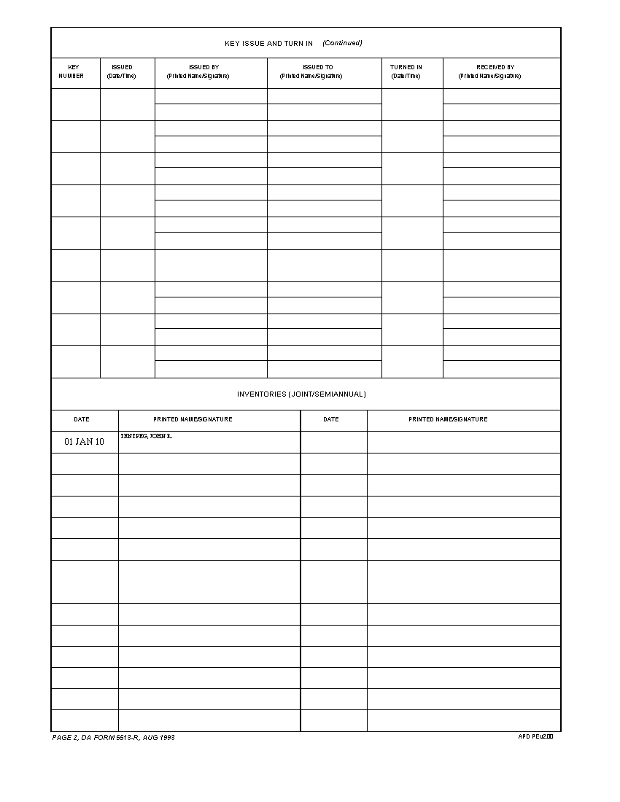ANNEX L (SAMPLE HAND RECEIPT FOR ALTERNATE KEYS TO S-2) TO ARMS ROOM STANDARD OPERATING PROCEDURES

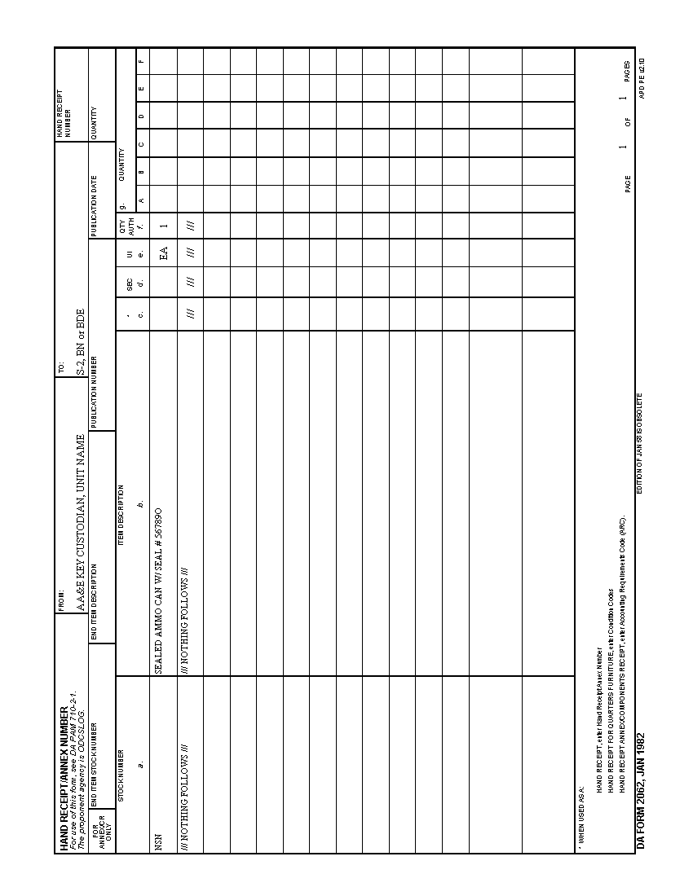
ANNEX M (SAMPLE WEAPON CONTROL LOG) TO ARMS ROOM STANDARD OPERATING PROCEDURES
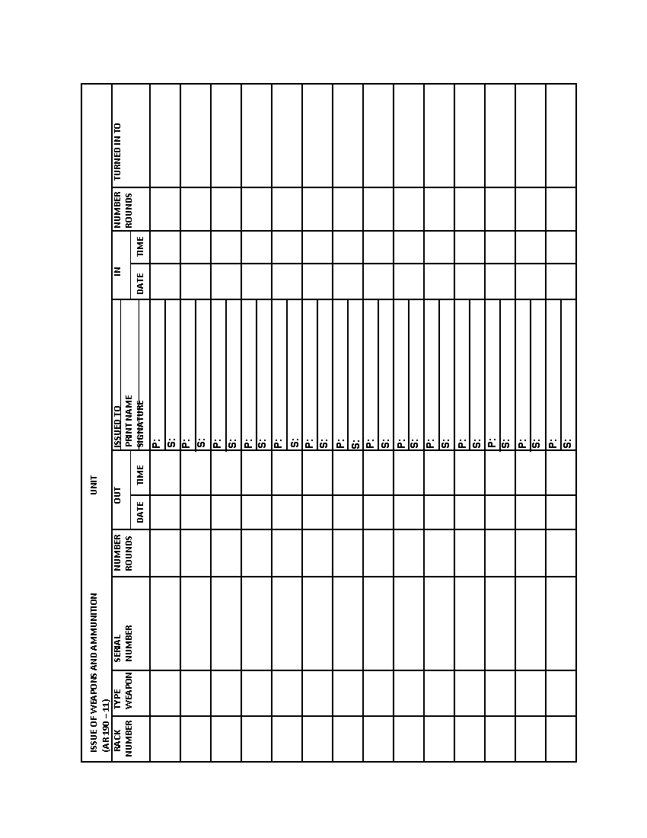
ANNEX N (SECURITY OF DEPLOYED AA&E ITEMS) TO ARMS ROOM STANDARD OPERATING PROCEDURES

- Purpose: To provide guidance to personnel having responsibility for the protection of deployed Arms, Ammunition and Explosive (AA&E) items.

- Scope: This TACSOP applies to all assigned or attached personnel.

- Procedures:

- The deploying Commander will establish and enforce procedures for securing deployed AA&E based on an assessment of the threat, objectives, location, and duration of deployment. The following guidelines apply:

- AA&E will be under continuous positive control, by a minimum of two authorized/designated personnel.

- AA&E will not be left unattended or unsecured.

- Persons charged with custody of AA&E will have the capability to call for help if a theft is attempted.

- A response force will be available to protect the AA&E. Where available, Military Police support will be coordinated and utilized as the response force.

- A system of supervisory checks will be established to ensure all personnel comply with security procedures. Supervisory checks of the AA&E holding area will be made to ensure the AA&E being guarded have not been tampered with.

- Control of ammunition and explosives during field training or range firing will be monitored closely by all officers and NCOs. Upon completion of training, the training area(s) will be policed, and unused ammunition and explosives collected for turn-in. A shakedown inspection will be conducted prior to departing the training area to ensure unused ammunition and explosives are not retained by unit personnel. Close supervision by officers and NCOs can eliminate most security problems in the training area.

- Selection of personnel to perform guard duties at AA&E holding areas will be closely monitored by Commanders to ensure only responsible individuals are assigned to duty.

- Individual Weapons Security.
- Each weapon issued for training, operations, or any other reason will be carried on the person to whom issued at all times or it will be properly secured. Except during emergencies (terrorist attack, military attack, or other situations specified by the Commander), weapons will not be issued to any person other than the primary weapons card holder unless that person is charged with the security of operational weapons.

- Proper security is provided when weapons are under continuous surveillance by a dedicated guard and in locked containers, stacks, or secured with chains and locks.

- Personnel medically evacuated during training exercises will relinquish their weapon(s) to the armorer, immediate chain of command, or highest-ranking Service Member. This person will either accompany the evacuation team or leave the weapon(s) in the field arms storage area. The armorer will annotate on the weapons sign-out sheet that the weapon has been returned and retain the weapons card(s) with the weapon(s) until the Soldier returns to duty.

- During training and field exercises, pistols and revolvers issued to persons will be secured by either a locally made lanyard or military issue field lanyard authorized by CTA 50-900 (NSN 8464-00-964-1705). Unloaded pistols and revolvers that lack a device to affix the lanyard will be secured by running the lanyard through the pistol trigger guard and secured to the soldier's uniform. A lanyard will not secure a pistol or revolver through the trigger guard if the weapon is loaded.

- The Officer/NCO in charge at the deployment site/location will provide any additional instructions.

