DEPARTMENT OF THE ARMY
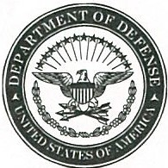

XXXXXXXXXXXXXXXXXXXX
XXXXXXXXXXXXXXXXXXXX
XXXXXXXXXXXXXXXXXXXX

OFFICE SYMBOL Date

MEMORANDUM THRU Commander, XXXXX

FOR XXXXX

SUBJECT: Financial Liability, Investigation of Property Loss XX-XX, $XXXX.XX, Receipt Acknowledgement Memo

- I hereby acknowledge receipt of notice recommending me for charges of financial liability contained in the basic correspondence above. A copy of DD Form 200 with blocks 16a through 16h completed is returned as requested.

Encl FIRST M. LAST
FLIPL #XX-XX XXX, XX

