DEPARTMENT OF THE ARMY
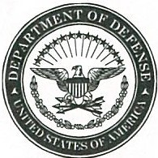

XXXXXXXXXXXXXXXXXXXX
XXXXXXXXXXXXXXXXXXXX
XXXXXXXXXXXXXXXXXXXX

OFFICE SYMBOL Date

MEMORANDUM THRU Commander, XXXXX

FOR XXXXX

SUBJECT: Financial Liability, Investigation of Property Loss XX-XX, $XXXX.XX, Unreturned DD 200 and Receipt Memo

- On XX XXXX XX, a notification letter and DD form 200 was sent to XXX FIRST LAST regarding his/her Financial Liability Investigation of Property Loss. The suspense date to return the memo was XX XXXX XX As of XX XXXX XX, no response had been received by the Investigating Officer (the undersigned), and there was confirmation that the letter was delivered to the Service Members last known address (Enclosed).

- Point of contact for this memorandum is the undersigned at (123) 456-7890 or first.m.last.mil@mail.mil.

Encl FIRST M. LAST
FLIPL #XX-XX XXX, XX
Investigating Officer

